Group 3: Kevin Bader, Shayna Chernak, Grace Cote, Irina Yeager

UPENN-PHI-DATA-PT-09-2020-U-C

Project 2 Report

February 6th, 2021

*Github Repository*: https://github.com/khbader101/Project_2

*Powerpoint Presentation*: https://docs.google.com/presentation/d/1tNhg-ThOvDOChXYJOWPBh03rXoqAQAsDNHr6-jHo-xQ/edit?usp=sharing

**Ready Player One: The Battle for Best Mobile Strategy Game Developer**

*Background*

Unlike shooter and driver games, mobile strategy games test players’ decision-making skills versus another player or computer. According to *Britannica*, electronic strategy games stem from board games and began gaining popularity as early as the 1940s. Although they are considerably well-liked today, mobile strategy games have declined in popularity in recent years. Downloads in the United States from January 2019 to October 2019 reached a peak of 120 million (Statista). Mobile game strategy downloads during the same time period in 2020 fell to 113 million (Statista). Gaming blogs and gamer influencers often discuss this genre of electronic game. However, users are also free to leave ratings on each game in their respective app stores, leaving a more accurate portrayal of the public’s opinion on a game.

*Project Details*

Sourced from an iTunes API, the data used for this project has listed over 17,000 games with over 15 different measures and dimensions about the game, such as the genre, user rating, developer, and even the languages the app comes in (kaggle.com). For this project, the data is looking at ratings at the developer level. The created dashboard looks at the number of games, average users per game, and average ratings while also looking at several dimensions, such as the game price and primary genre.

Figure 1: Screenshot of dashboard

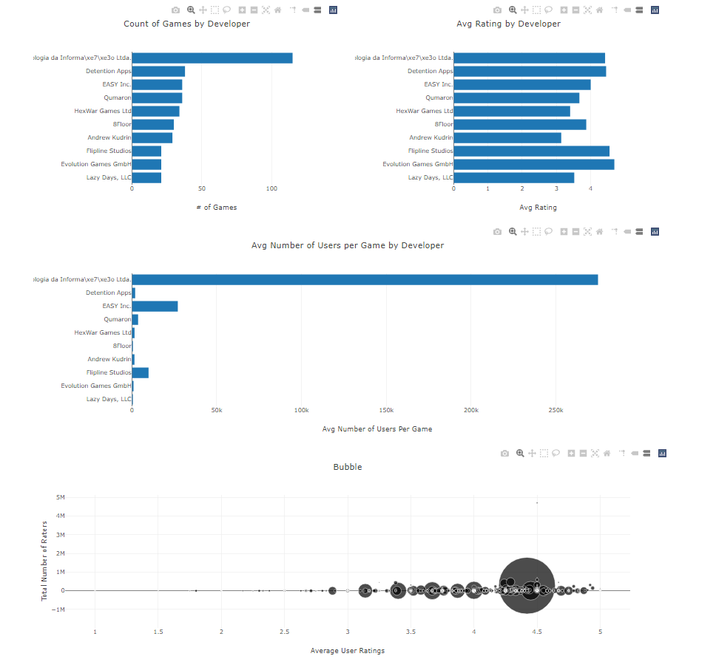

The first bar graph displays the number of games by developer. Getting a general overview of how many games each developer has will help to give perspective on the variability. One can see that *Tapps Tecnologia da Informa\xe7\xe3o Ltda* stands as the developers with the most games within the dataset, followed closely by *Detention Apps*. When slicing by price, *Tapps Tecnologia da Informa\xe7\xe3o Ltda* has the most free apps while *Detention Apps* has the most paid apps.

Figure 2: Count of Games by Developer

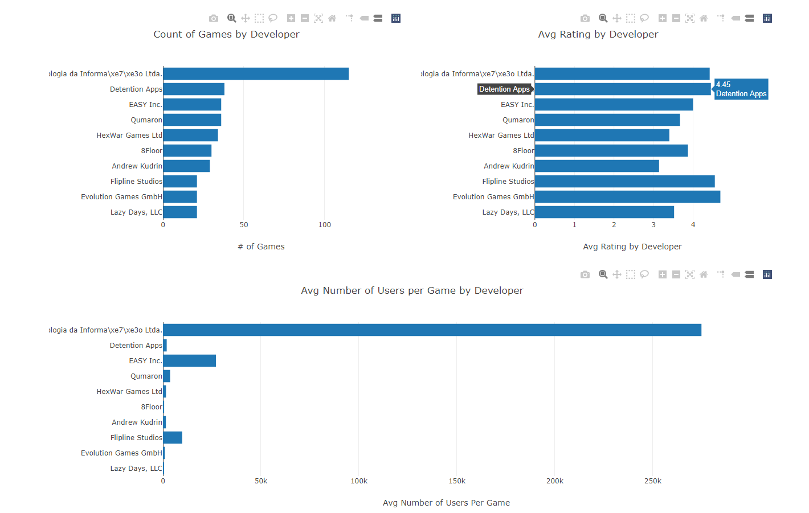

The second bar graph displays the average number of users by developer. Taking into account that developers do not have the same number of games, the average number of users rating the games gives a better picture of who is rating the developers. *Tapps Tecnologia da Informa\xe7\xe3o Ltda*  looks to have the most average user ratings, while *EASY Inc* has the next highest average number of users per game. When slicing by price, *Tapps Tecnologia da Informa\xe7\xe3o Ltda*  has the most ratings on free apps and Detention Apps has the most ratings on paid apps.

Figure 3: Average Number of Users per Game by Developer



The third bar graph displays the average rating for developers who have over 25 games. If we were to show developers of all sizes, there would be an overwhelming number of developers with a rating of 5.0 simply because they have one or two apps. Limiting the developer size can provide us with a better picture of the ratings. When comparing, *Evolution Games GmbH* has the best rating.

Figure 4: Average Rating by Developer



The bubble chart brings everything displayed in a bar chart together as a better comparison of the dataset. Comparing the average number of user ratings versus the average rating, one can see the largest circle represents *Tapps Tecnologia da Informa\xe7\xe3o Ltda.* Circles are sized by how many apps the developer created in the dataset and colored by price.

Figure 5: Scatter Plot of Competitive Landscape

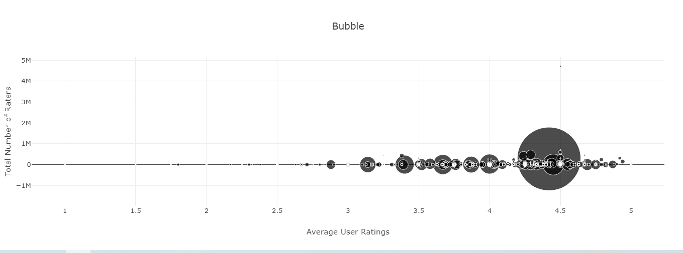

*Summary of Data*

Through our analysis, we found several interesting data points examining users’ opinions of developers’ games, as well as the popularity of developers themselves. First, we explored the number of games per developer, which revealed a small number of developers are the most prevalent in the mobile strategy game genre. This revealed that *Tapps Tecnologia da Informa\xe7\xe3o Ltda* and *Detention Apps* are the developers producing the highest number of games. Next, we investigated which developer accumulated the highest average ratings by plotting the average ratings of users by developer. This analysis showed *Evolution Games GmbH* are the developers with the highest average number user ratings. Our third graph analyzed the average number of users per developer. This displayed that *Tapps Tecnologia da Informa\xe7\xe3o Ltda* has the highest number of users per developer by a margin of over 200,000 players. Our final analysis, displayed through a bubble graph, compares the average number of user ratings versus the total number of users that left a rating. This visual representation of data gives a better picture of how popular developers’ products are.

*Discussion*

When completing the initial research, the data looks geared to stakeholders looking into app details. For example, financial investors may want to view this data when comparing which developer to invest in. They may be looking to invest in a developer with the most apps, the highest ratings, or the most paid apps. As another example, advertisers may want to view this information if they are looking to advertise products via in-app ads. The number of ratings and average ratings give us not only an idea of how many impressions we could receive, but also the perception users have towards the games. The association with the app to the advertisement could impact consumers in a positive or negative way depending on the situation. As an example, if an app has low ratings, the products advertised within that app could be considered low quality or bad products. It would also be a bad decision on the advertiser’s part to advertise in a low-rating game as the impressions may be lower than that of a high-rated game. One other stakeholder that cares about app ratings are phone manufacturers and developers. Apple needs to have consumers download the apps, so they want to know what the best apps and developers are to recommend to their customers, mainly through search engine optimization. The developers themselves would also want to see this data to see where they are in the competitive landscape of the industry. If a specific developer has lots of games but low ratings compared to those with similar number of games, they may want to spend some more time in researching why those games have lower

The data was pulled at the developer level. If looking at next steps, one could pull the data at the game level and find more information about specific games. In addition, there were some dimensions that were not pulled from the view that may have an association with one of the measures researched. In addition, if geographic data was available, besides what language the apps come in, one could see if there was an association with a certain developer being more popular in ratings in certain areas of the world.

With over 17,000 apps across over 4,000 developers, this large micro-industry has truly taken over. With these developers coming out of the woodwork in a saturated market, it is imperative to see who is doing the best. Given our dashboard, stakeholders have an easier way of hashing through the important data.